**Clinically relevant autistic traits predict greater reliance on detail for image recognition**

*Arjen Alink1 & Ian Charest2*

**Supplementary Information**

*1University Medical Centre Hamburg-Eppendorf, Germany*

*2University of Birmingham, United Kingdom*

**Corresponding author**

Arjen Alink

[a.alink@uke.de](mailto:a.alink@uke.de)

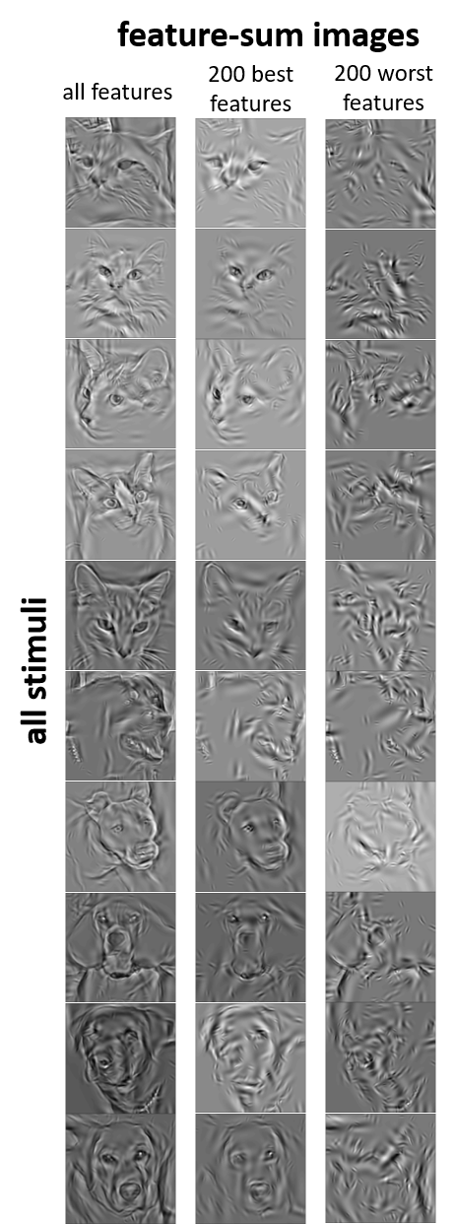

**Supplementary figure** showing the sum of all 1000 Gabor wavelet features for all 10 images used during the experiment and the 200 best and worst features based on their associated FDi values (across all participants)